PRoTECT kick-off meeting  
10 – 11 december2018

# Location

The PRoTECT kick-off meeting will take place in ‘s-Hertogenbosch, Netherlands at DITSS office:

The address of the venue is:

Campus Mariënburg  
Sint Janssingel 92  
5211 DA 's-Hertogenbosch (also know as Den Bosch)  
The Netherlands

# Project information

Identification: project n° **815356**

Duration: 24 months

Latest version of the proposal: the contractual version of the proposal is available online through the ECAS system.

Start date: 01/11/2018

End date: 31/10/2020

# Goal of meeting

The goal of the meeting is to initiate the concrete activities of PRoTECT; therefore the kick-off is the first *operational meeting*. It is important to keep in mind this goal; therefore we are expecting that each partner will be represented at this meeting by the people who will actually be involved in implementing the work.

The first deadlines for results are at M1, and **we have 14 deliverables to be issued during the first 12 months**. The breakdown of deliverables is the following:

|  |  |
| --- | --- |
| Total number of Deliverables | 25 |
| Year 1 Deliverables | 14 |
| Year 2 Deliverables | 11 |

The meeting is focused on the period M1 to M12 in terms of deliverables.

# Agenda

|  |  |  |
| --- | --- | --- |
| Day 1: 10/12/2018 – 14:00-18:00 | | |
| 14:00 – 15:00 | Participant registration |  |
| 15:00 – 15:30 | Introduction to the meeting  Tour de table – participants | Patrick Padding (DITSS/ENLETS)  ALL |
| 15:30 – 16:00 | Project Overview | Peter van de Crommert (DITSS) |
| 16:00 – 17:00 | Partners’ presentation (5 minutes each) | All |
| 17:00 – 17:30 | **Break** | |
| 17:30 – 18:30 | WP1 - Project management  D1.1 – Project Reference Manual Tool | Peter van de Crommert and Georgios Kioumourtzis (DITSS) |
| 20.00 | **Social Dinner** | |

|  |  |  |
| --- | --- | --- |
| Day 2: 11/12/2018 – 09:30-16:00 | | |
| 09:30 – 10:30 | WP1 – Management and Coordination of the Action | DITSS |
| 10:30 – 12:00 | WP2 – Vulnerability Assessment | EFUS |
| 12:00 – 13:00 | **Lunch Break** | |
| 13:00 – 14:00 | WP3 – Technology Assessment and Open Calls | JADS |
| 14:00 – 15:00 | WP4 – Training and Demonstrations | KEMEA |
| 15:00 – 15:30 | **Coffee Break** | |
| 15:30 – 16:30 | WP5 – Dissemination and Communication | DITSS |
| 16:30 – 17:00 | Wrap-up and conclusions | DITSS |
| 17:00 | End of the meeting |  |

# How to reach the venue

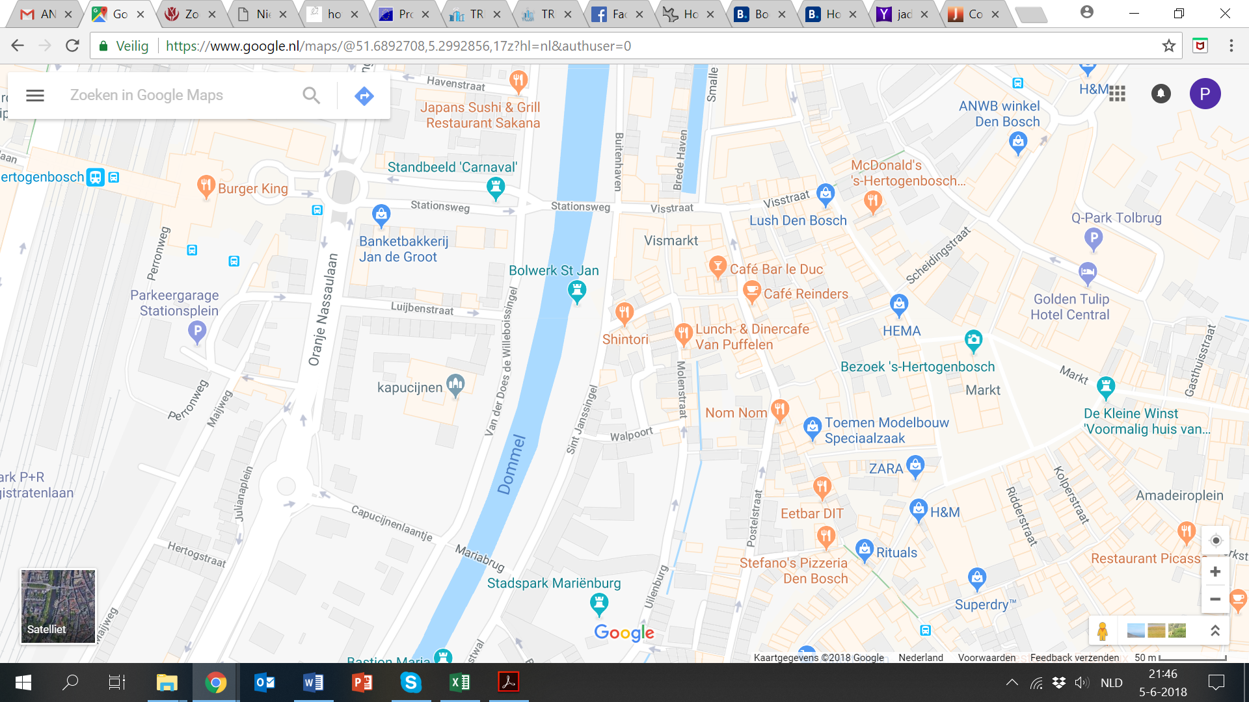

Railway

Station

DITSS/JADS

**Airports:**

**Schiphol Airport Amsterdam**

**Eindhoven Airport**

**By train**

* There are regular trains from Schiphol Airport train station to ‘s-Hertogenbosch.
* There are regular trains from Eindhoven Central Station to ‘s-Hertogenbosch.
* Public Transport from Eindhoven airport to Eindhoven railway station: <https://www.eindhovenairport.nl/en/public-transport>
  + Once arriving and leaving the 's-Hertogenbosch station walk straight until you cross a bridge over a river (3-5 min walk).
  + Turn right into the Sint Janssingel and walk until you reach the entrance of the old monastery with 'Mariënburg' above the entrance on your left side (2-4mins). This is the entrance to the JADS Mariënburg Campus.

# Nearby Hotels

|  |  |  |  |
| --- | --- | --- | --- |
| **Hotel Name** | **Category** | **Location** | **Contact details** |
| Golden Tulip Hotel Central | **** | Burgemeester Loeffplein 98 5211 RX ’s-Hertogenbosch  (+/- 5 min walk) | <https://www.hotel-central.nl/> |
| Best Western Eurotel | **** | Kerkstraat 56, 5211 KH Den Bosch, Nederland  (+/- 5 min walk) | <http://eurohotel-denbosch.nl/en/> |
| Van der Valk  ’s-Hertogenbosch -Vught | **** | Bosscheweg 2, 5261 AA Den Bosch, Nederland  (Taxi needed: 5 Euro one way) | <https://www.hotelvught.nl/en> |
| Several B&B’s | 3 to 5 star | City Centre | [www.booking.com](http://www.booking.com) Search for  ‘s-Hertogenbosch or Den Bosch |